**TUẦN 12 – AV9**

**THEME 4: LEARNING A FOREIGN LANGUAGE**

**READ – LANGUAGE FOCUS**

**READ:** [**https://youtu.be/rKbdD6Jfdr4**](https://youtu.be/rKbdD6Jfdr4)

**LANGUAGE FOCUS:** [**https://youtu.be/o1Wr_sOLwLM**](https://youtu.be/o1Wr_sOLwLM)

1. **READ ( Học sinh tự học)**

Vocabulary:

1. intermediate (adj.) : trung cấp

2. level (n) : cấp, mức độ

3. tuition (n) /tjuˈɪʃn/: việc học kèm

4. improve (v) : cải thiện, làm cho tiế bộ

5. academy (n) / əˈkædəmi /: học viện

6. qualified (adj.) / ˈkwɒlɪfaɪd / : có trình độ chuyên môn

=> Qualified for something

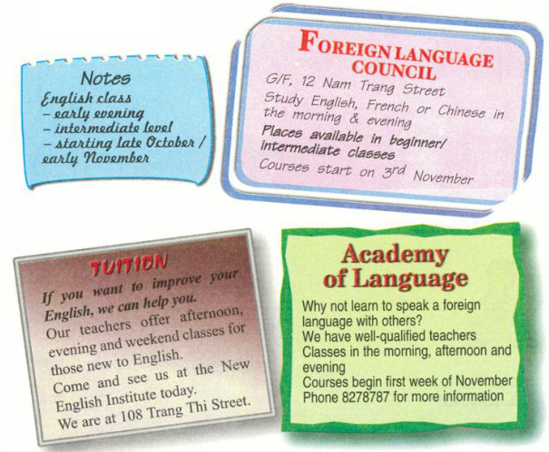

**Task 1: Note down information about the English classes from the advertisements.**

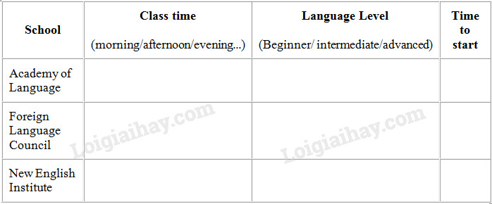

**Answer keys:**

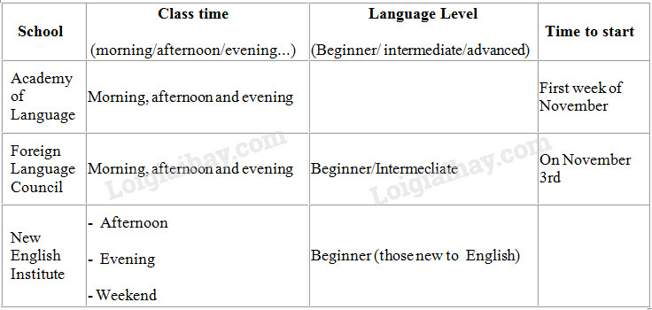

**Bài 2**

**Task 2. Read the notes Mr. Lam made. Then look at the advertisements and choose a suitable language school for him . Give the reasons for your choice.**

**Answer keys:**

- Mr.Lam should take an English course at Foreign Language Council due to following reasons:

+ There are classes in the evening.

+ There are classes for beginners and intermediate level students.

+ Courses start on November 3rd.

1. **LANGUAGE FOCUS**
2. **REPORTED SPEECH**

***ĐỔI THÌ CỦA ĐỘNG TỪ***

|  |  |
| --- | --- |
| ***DIRECT SPEECH*** | ***REPORTED SPEECH*** |
| ***Present simple***  *V(bf)/ Vs- Ves*  *Am/ is/ are* | ***Past simple***  *V2/ V-ed*  *was/ were* |
| ***Present progressive*** *(am/ is/ are + V-ing)* | ***Past progressive*** *(was/ were + V-ing)* |
| ***Past simple*** *(V2/ V-ed)* | ***Past perfect*** *(Had + V3/ Ved)* |
| *Can* | *Could* |
| *Will* | *Would* |
| *Must/ have to* | *Had to* |

***ĐỔI CÁC ĐẠI TỪ, TRẠNG TỪ CHỈ THỜI GIAN VÀ ĐỊA ĐIỂM***

|  |  |
| --- | --- |
| ***DIRECT SPEECH*** | ***REPORTED SPEECH*** |
| *Today* | *That day* |
| *Now* | *Then* |
| *This/these* | *That/ those* |
| *Here* | *There* |
| *Yesterday* | *The day before* |
| *Tomorrow* | *The following day* |
| *Next month* | *The following month* |
| *ago* | *before* |

**Statement**

**Ex: a.** “I**’m** happy to see you”, Aunt Xuan said

**⭢** Aunt Xuan said (that) *she* **was** happy to see me

**b.** “I **will** go to Hue tomorrow”, Mr. Nam said

**⭢** Mr. Nam said (that) *he* **would** go to Hue the following day.

**Yes / No question:**

* + “Do/ does + S + V (bf)…?”  
    S + asked ….+ if/ whether + S + V2/ Ved…
  + “ Am/ is/ are + S…?”

S + asked ….+ if/ whether + S + was/ were…

* + “ Can + S + V (bf)…?”

S + asked ….+ if/ whether + S + could + V (bf)….

* + “ Will + S + V(bf)…?”

S + asked ….+ if/ whether + S + would + V (bf)….

**Ex:** **a**. “**Do** you **like** pop music?”, she asked

⭢ She asked me ***if*** *I* ***liked*** *pop* music.

b. “ **Can** you **speak** any languages?”, the examiner asked her

⭢ The examiner asked her ***if*** *she* ***could*** *speak* any languages.

**Wh- questions** :

* + - * 1. “Do/ does + S + V(bf)…?”,..

🢣….Wh- questions + S + V2/ Ved…(bỏ Do/ does)

* + - * 1. “ Am/ is/ are + S…?”,….

🢥 ….Wh- questions + S + was/were……

* + - * 1. “ Can + S + V (bf)…?”,…

🢣 ….Wh- questions + S + could + V(bf)……

* + - * 1. “ Will + S + V(bf)…?”,…

🢣 ….Wh- questions + S +would + V(bf)……

Ex: a. “ **Where** **do** you **live**?”, she asked me

🢥 She asked me ***where I lived.***

**b**. “**What** **is** *the name of your school*?”, she asked me.

🢣 She asked me **what** *the name of my school* **was**.

**Command (Câu mệnh lệnh)**

**S+ asked/ told** + O + **to Verb** (base form)

**S+ asked / told** + O + **not + to Verb** (base form)

**Ex:**

**a**. “ **Chew** well while **you’re** **eating**,” he asked me

⭢ He *asked* me **to chew** well while I was eating.

**b**. “ **Don’t** ask *these* silly questions,” The teacher told us

⭢ The teacher *told* us **not to ask** *those* silly questions.

1. **THE CONTITIONAL SENTENCES**

THE CONDITIONAL SENTENCES: Câu điều kiện

|  |  |  |  |
| --- | --- | --- | --- |
| **CONDITION** | **IF- CLAUSE**  **(Mệnh đề if )** | **MAIN CLAUSE**  **(Mệnh đề chính)** | **NOTES** |
| Modal Verbs with If | Simple present | S+ modal verbs+ Verb (base form) | 1. **He** should ask **somebody** *if* **he** wants **to get out of this place** 2. *If* **she** is **lucky, she** may pass **the test.** |
| Type 0 | Simple present (Thì hiện tại đơn)  S + Vbf/ Vs/ Ves  I/ We/ You/ Dtừ số nhiều+ Vbf  He/ She/ It/ dtừ số ít+ Vs/ Ves  * Thề phủ định  I/ We/ You/ Dtừ số nhiều+ don’t + Vbf  He/ She/ It/ dtừ số ít+ doesn’t + Vbf | Simple present | ***Dùng để diễn tả một việc tất yếu sẽ xảy ra, tiếp theo là một sự việc khác.***  **Ex:** *If* **the door bell** rings**, the dog** barks**.** |
| Type 1  Real/ Probable | Simple present  (Thì hiện tại đơn) | Simple future  (Thì tương lai đơn)  S+ Will + Vbf | ***Dùng để diễn tả một việc có thật, có thể xảy ra trong hiện tại hoặc tương lai.***  **Ex:** *If* **we** don’t hurry**, we** will miss **the train.** |

**Task 1. Complete the sentences. Use the modal verbs in brackets and the information in the box.**

|  |
| --- |
| stay / bed                  do / homework          do / exercise  go / university            study hard                miss / train |

a) Lan: My grades are terrible.

Mrs. Quyen: If you want to get good grades, you ***must***study hard.            (must)

b) Hoa: I'd like to be a doctor.

Aunt Thanh: You ***have to*** go to university if you want to study medicine.              (have to)

c) Ba: Oh, no! I weigh 60 kilos!

Nga: If you want to lose weight, ...                     (should)

d) Tuan: Where is Ba? He's very late.

Mrs Thoa: If he doesn't come soon, ...                  (might)

e) Mr. Ha: I feel sick

Mrs Nga: If you want to get well, ...                 (ought to)

f) Na: I'd like to go to the movies, Mom.

Mrs. Kim: ... if you want to go out.                          (must)

**ANSWER KEYS:**

c) Ba: Oh, no! I weigh 60 kilos!

Nga: If you want to lose weight, you **should** do exercise.

d) Tuan: Where's Ba? He's very late.

Mrs. Hoa: If he doesn't come soon, he **might** miss the train.

e) Mr. Ha: I feel sick.

Mrs. Nga: If you want to get well, you **ought to** stay in bed.

f) Na: I'd like to go to the movies.

Mrs. Kim: You **must**do your homework if you want to go out.

**Task 2. Complete the table.**

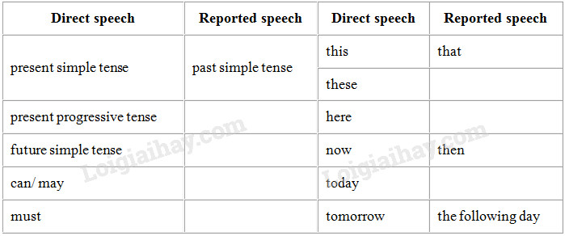

**Lời giải chi tiết:**

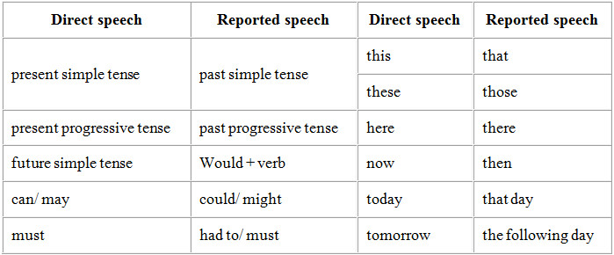

**Task 3. Lan’s father held a party to celebrate his mother’s birthday. Unfortunately,Mrs Thu, her grandmother, has a hearing problem and she couldn ’t hear what people were saying. After the party, Lan reported everything to her grandmother.**

Example: “I’m happy to see you.”                         (Aunt Xuan)

Aunt Xuan said she was happy to see you.

a) “This birthday cake is delicious.”                 (Uncle Hung)

b) “I love these roses.”                                      (Miss Nga)

c) “I’m having a wonderful time here.”              (Cousin Mai)

d) “I will go to Hue tomorrow.”                           (Mr. Chi)

e) “I may have a new job.”                                (Mrs. Hoa)

f) “I must leave now.”                                        (Mr. Quang)

**ANSWER KEYS:**

a) Uncle Hung said that the birthday cake was delicious.

b) Miss Nga said (that) she loved the roses.

c) Cousin Mai said (that) she was having a wonderful time there.

d) Mr. Chi said he would go to Hue the following day.

e) Mrs. Hoa said she might have a new job.

f) Mr.Quang said he had to leave then.

**Task 4. This morning Nga had an interview for a summer job. When she arrived home, she told her mother about the interview.**

Example:

“Do you like pop music?”

⟹ She asked me if I liked pop music.

or She asked me whether I liked pop music.

“Where do you live?”

⟹ She asked me where I lived.

a) “How old are you?”

b) “Is your school near here?”

c) “What is the name of your school?"

d) “Do you go to school by bicycle?”

e) “Which grade are you in?”

f) “Can you use a computer?”

g) “Why do you want this job?”

h) " When does your school vacation start?"

**ANSWER KEYS:**

a) She asked me how old I was.

b) She asked me if my school was near there.

c) She asked me what the name of my school was.

d) She asked me if I went to school by bicycle.

e) She asked me which grade I was in.

f) She asked me if I could use a computer.

g) She asked me why I wanted the job.

h) She asked me when my school vacation started.